Hamead Karimzad

108976200

09/08/24

Assignment 3: Amusement Park Final Part

Table Of Contents

1. **Requirements**  
   1.1 Train  
   1.2 Train Station  
   1.3 Train Track  
   1.4 Train Ride With At least One Stop  
   1.5 Animated Plane Ride  
   1.6 Castle  
   1.7 L-System Object  
   1.8 Appropriate Fencing
2. **Additions  
   1.1 A Water Feature Or Water Ride  
   2.2 Add Railway Crossing Gates  
   2.3 Keyframe and Physic Based Movement**
3. **Requirements** 
   1. Train  
      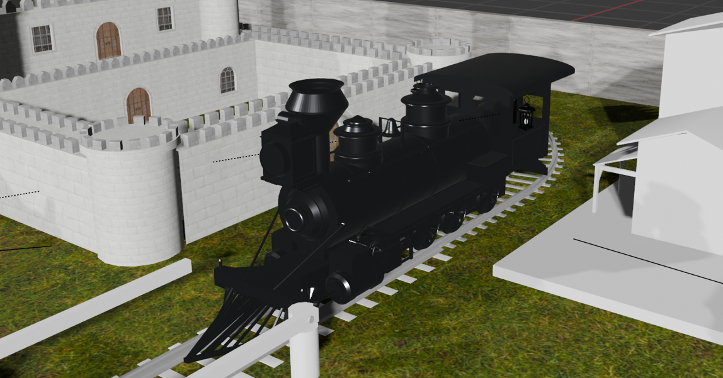

I successfully built a 3D model of a train in the scene. The model is fully detailed, textured, and properly scaled to fit within the environment.

* 1. Train Station

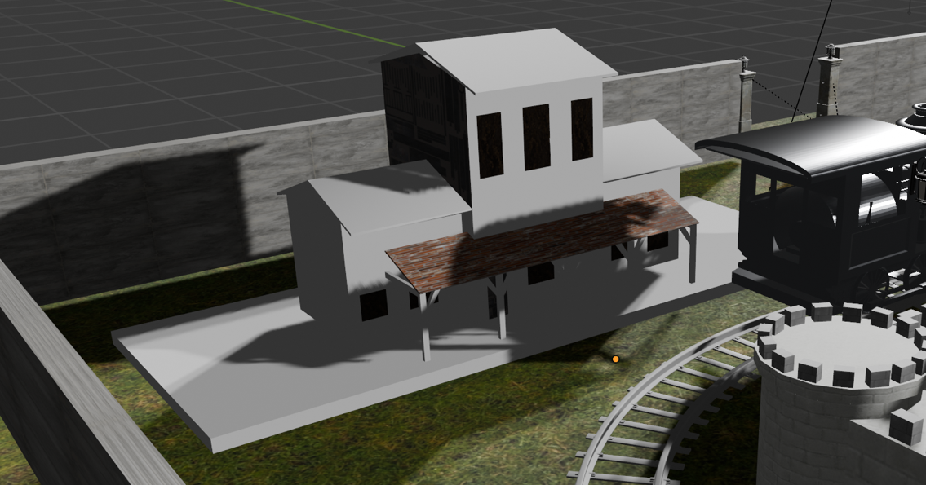

I modeled and placed a train station near the tracks. The station includes platforms and roofs, making it a functional and realistic part of the scene.

* 1. Train Track

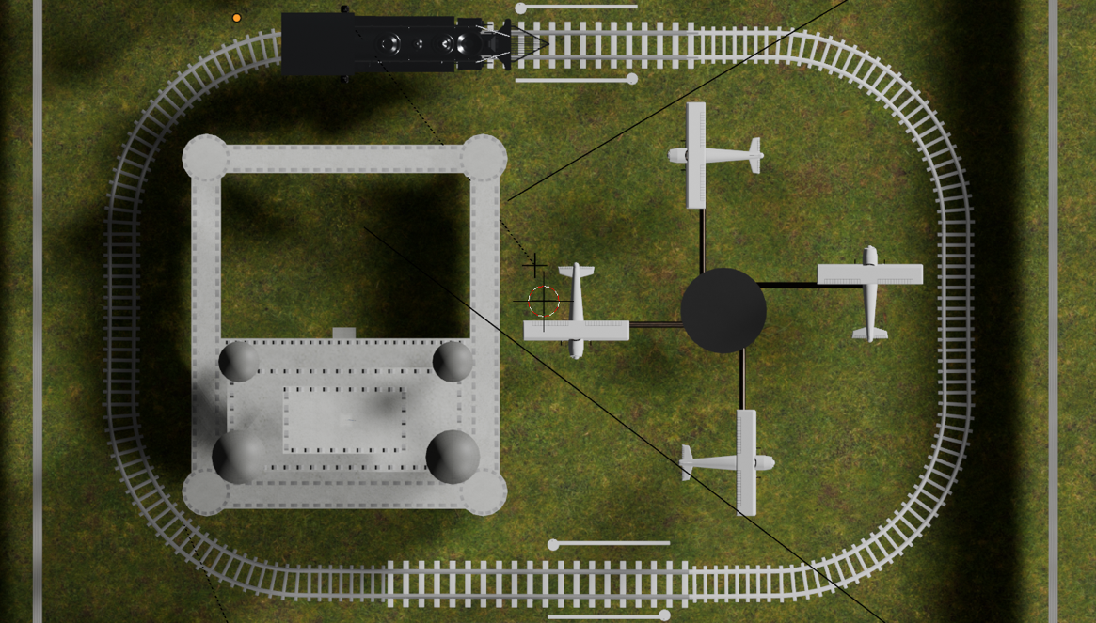

I created a continuous set of train tracks that are correctly aligned with the train model. The tracks are smoothly laid out to allow for realistic train movement.

* 1. Train Ride With At Least One Stop

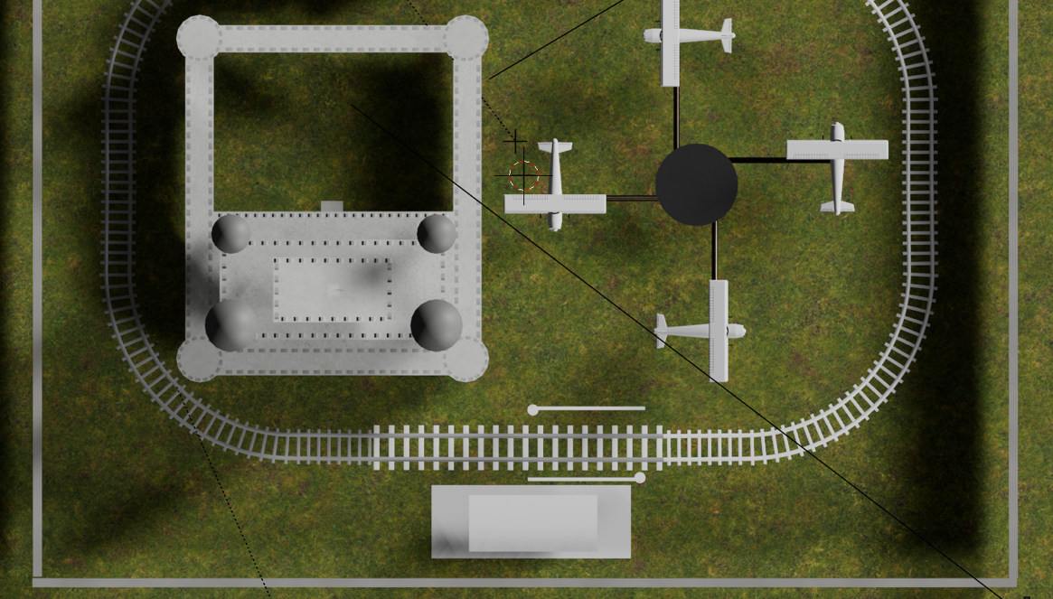

I modelled the train ride so that it has at least one stop. The stop is precisely timed and positioned at the bottom of the screenshot, creating a smooth and realistic ride.

* 1. 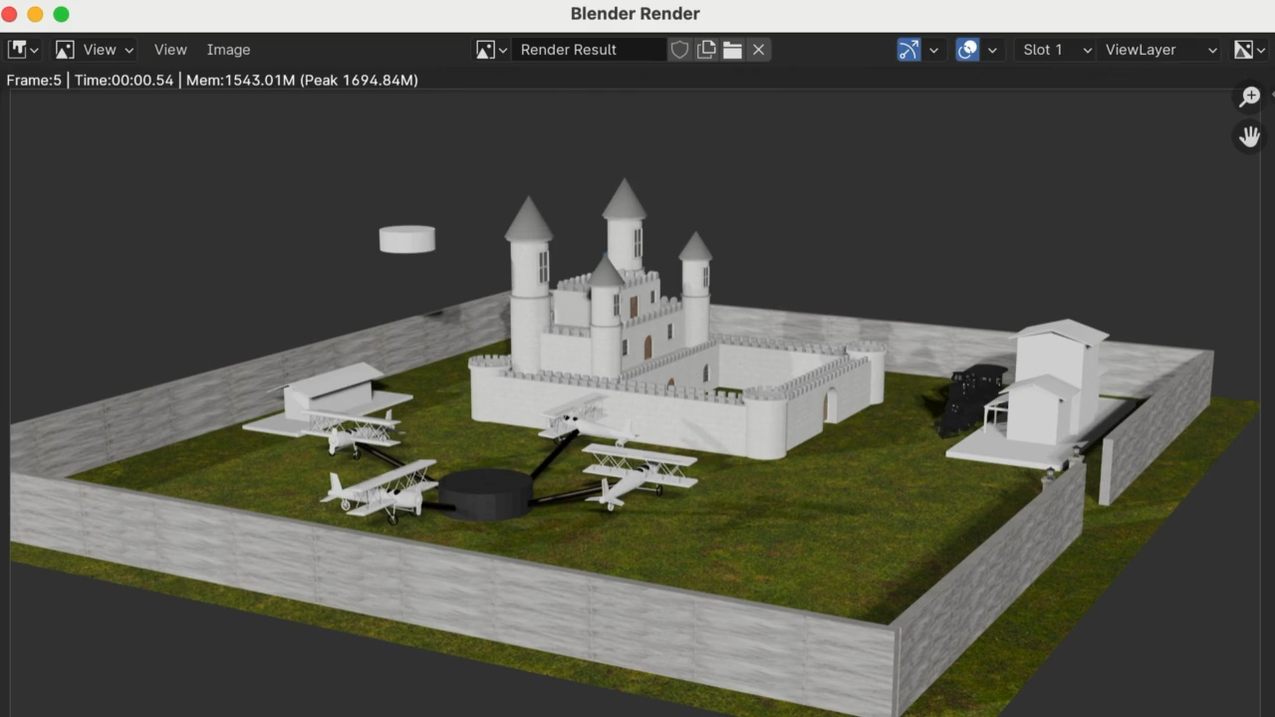Animated Plane Ride

I added an animated plane ride to the scene. The planes rotate in a merry go round type movement with fluid, realistic movements.

* 1. Castle

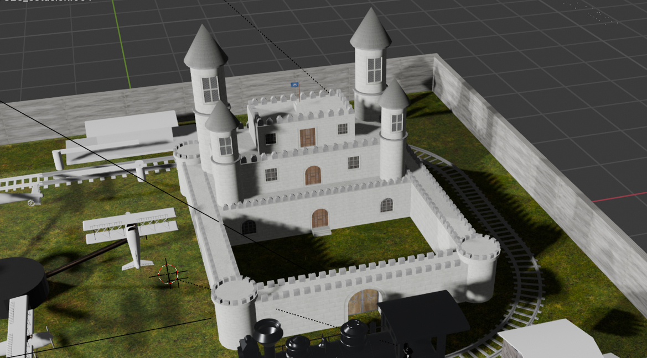

I built a detailed 3D model of a castle in the scene. The castle is properly textured and positioned, enhancing the overall environment.

* 1. L-System Object

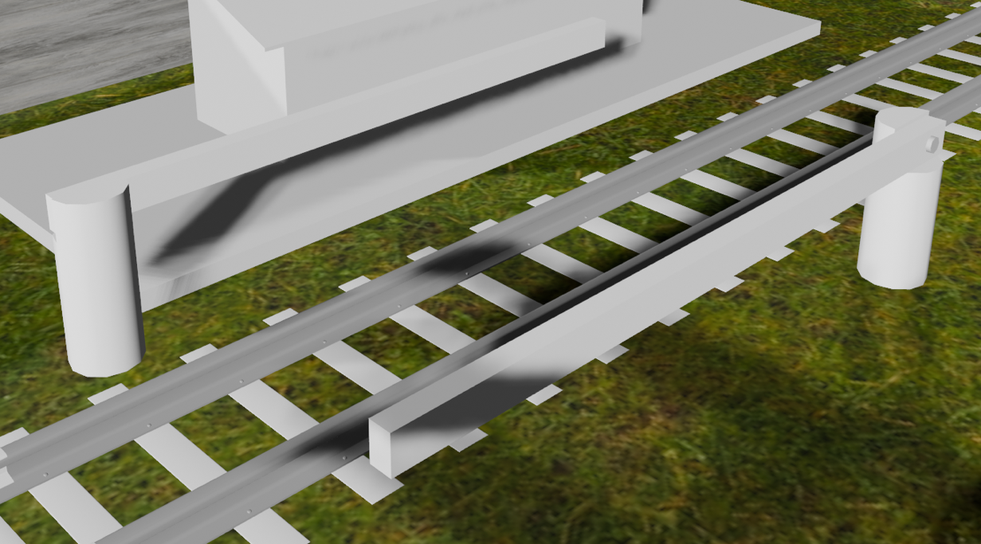

I generated and added an L-system object to the scene. These are to protect civilians from walking onto the tracks.

* 1. Appropriate Fencing

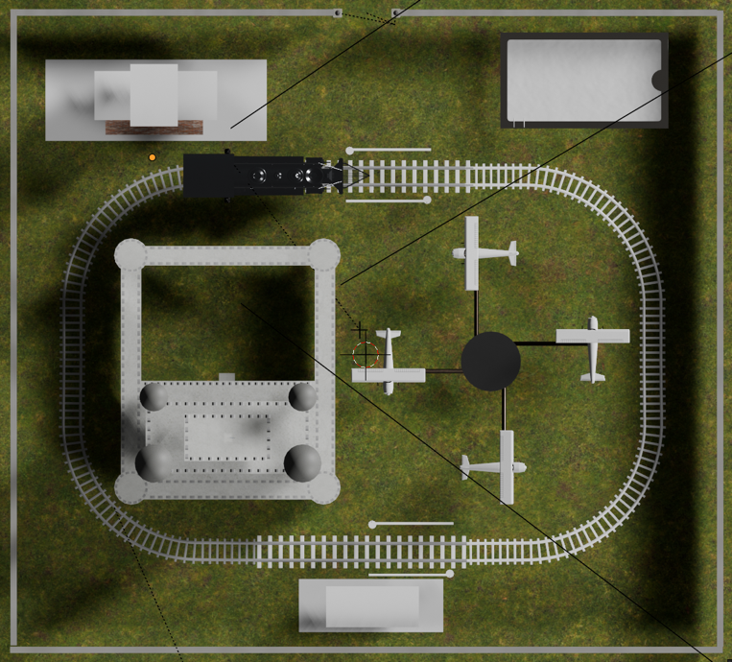

I added appropriate fencing around the amusement park in the scene. The fencing is correctly aligned and matches the overall style of the environment.

1. **Additions**
   1. **A Water Feature Or Water Ride**

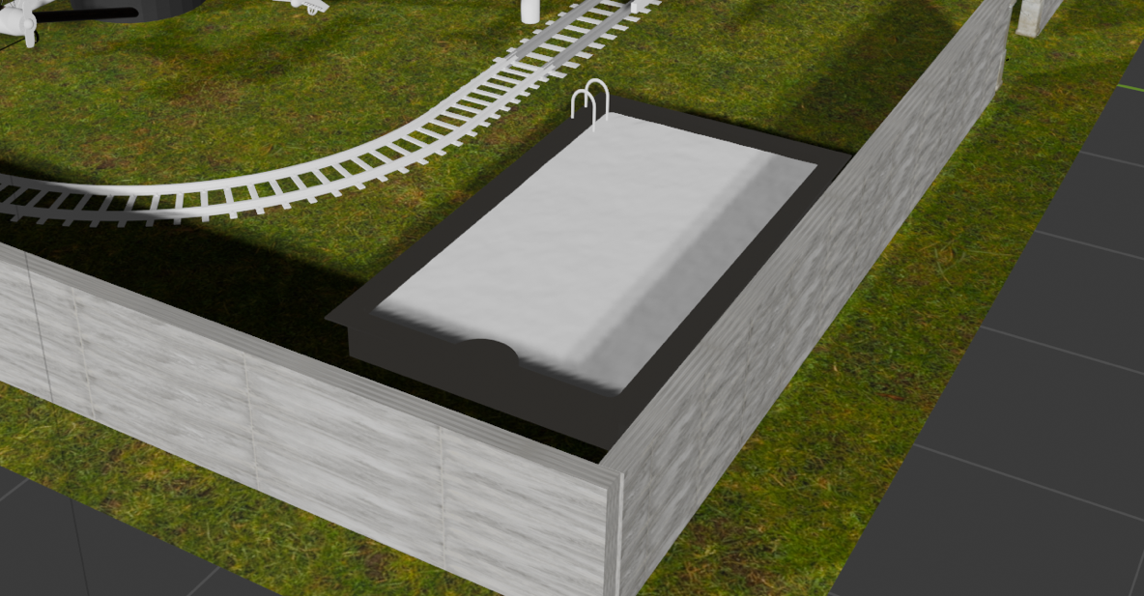

I successfully incorporated a water feature into the scene. It is an open area pool for guests to enjoy and adds a dynamic element to the environment.

* 1. **Add Railway Crossing Gates**

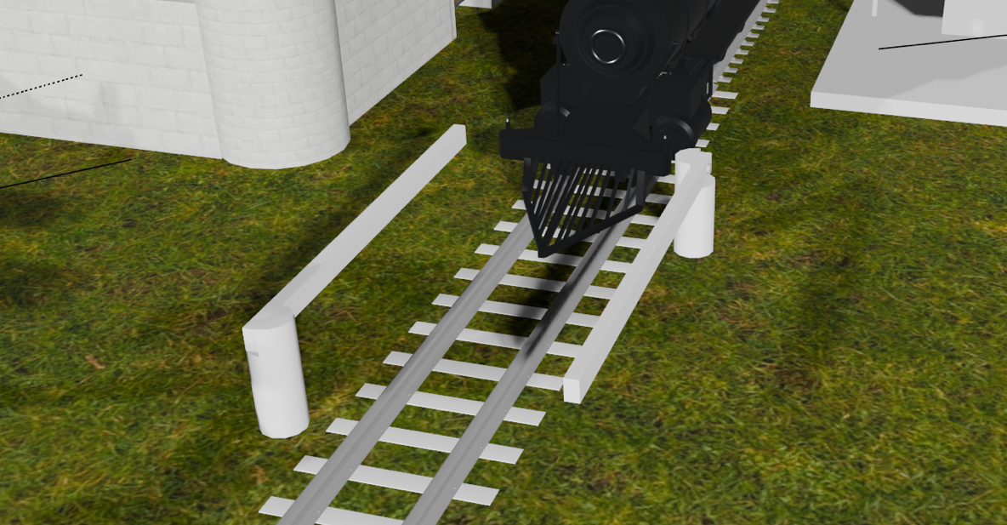

I added railway crossing gates near the train tracks

* 1. **Keyframe and Physic Based Movement**

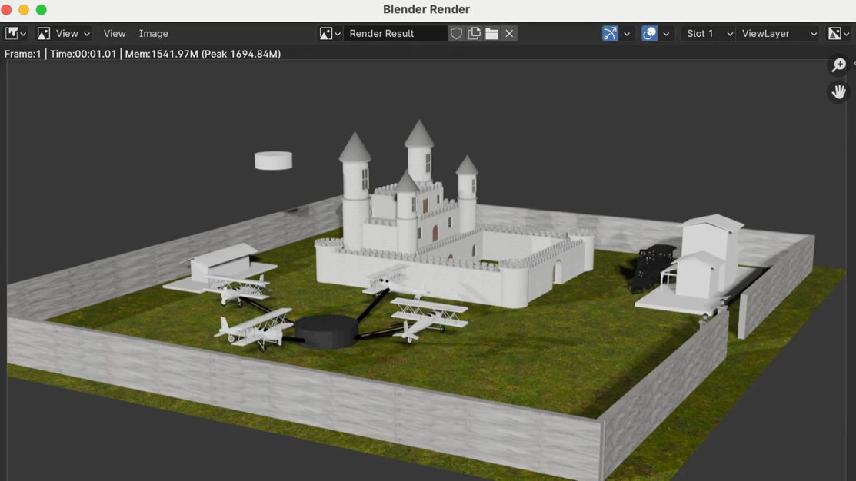

I applied keyframe animations and physics-based movement to various elements in the scene. This ensures that all objects move naturally and interact with the environment in a realistic manner.